BtS Unaltered Gameplay

Approval Process

Introduction
This document sets out how the BtS Unaltered Gameplay (‘BUG’) modifications changes the vanilla edition of Civ 4. It aims to address the issues that need to be addressed to get a mod approved at www.realmsbeyond.com. Unfortunately, there is no definitive process that must be followed to get a mod approved.
I have read various threads at realms beyond and gleaned the following items that summarize the mod approval process as I understand it.

Majromax Post of Feb 23rd, 2006
As I see it, mods broadly fall into 4 categories:
- Entirely cosmetic mods change or otherwise replace some of the stock Civ4 graphics with custom ones. Blue Marble is the supreme example of this: it doesn't make any gameplay changes, but entierly replaces the terrain sets. Also, (before, I believe, the latest patch), the commerce-icon mod would fall under this category.
These mods, in theory, don't make any new information available to the player, and are there primarily for aesthetic reasons.
- "Presentational" mods change, in some way, the interface of the game -- generally speaking, they'd make some aspect of the game's interface easier to use or more informative. The "improved" city management screen is one example, as is an "improved" foreign relation screen.
These mods can correct perceived flaws in the game's interface, but they are on a much shakier ground -- it is easy to reveal more information than the player should actually have. For example, at least one version of the foreign advisor mod allowed players to see how much gold an AI had for trade, even when the AI was in a "refuses to talk" stage of war declaration.
Mods which enhance the Civilopedia would probably also fall under this category, as would a hypothetical mod that changes (in some way) the combat odds display.
- "Utility" mods don't change the game itself, but provide some sort of additional functionality to the game player. The Autolog is probably the most popular example of a mod in this category. Likewise, anything that alters the "blue circle" advisor recommendations would fit here.
- "Content" mods change, in some basic way, the game's content. Anything which adds or changes a civ, tech, unit, terrain feature, improvement, resource, AI, or anything else actually used in Civ rules resolution would fall under this category. Since playing with one of these mods is, in a very fundamental way, not playing the same game of Civ as everyone else, these sorts of mods should be categorically banned. The only exception would be if some RB Tournament game actually required one, such as the Civ3 epic that ran on "one food/square" rules.

Sirian’s post of February 28th, 2006
APPROVAL PROCESS
What I need from "the committee":
- Is a mod "Graphical"? (Affecting appearance).
- Is a mod "Utilitarian"? (Affecting player's interface).
- Is a mod "Rebalancing"? (Affecting game rules).
- Which components are modified? (World Builder, XML, Python, C++)
- Which files are affected?
- If Python or C++ are involved, the mod needs to be certified free of trojans.
- VISUAL EVIDENCE showing and explaining what the mods actually do.
- A simple "aye" or "nay" from each committee member as to their personal recommendation on whether or not to approve a given mod. (Explanations may follow but are not required.)

Graphical-only mods would be approved for all uses (or not approved).
Mods with any rebalancing elements are off the table except for specific events (codifying a given event's variant rules in to the game itself.) The exception might be if I see a pressing need to override core game rules (including possible bugs or exploits yet to be discovered) to preserve the quality of our tournament; however, in that case I will write the mod myself and try to get it tested before imposing it on the rest of you. ... Here's hoping THAT is never necessary.
Utilitarian mods are the tough calls. Stuff like Civ3 Mapstat falls in to this category. Mods that are primarily graphical in nature can turn in to utilitarian mods, by design or by accident, so that's the main hurdle they face. It is my intent to approve all graphical mods that are shown to me to have no utilitarian or rebalancing effects. (I don't care what your game looks like. I only care how it plays. However, some graphics can affect gameplay, so that is where I start to care about those.)
Most utilitarian mods will not be approved, but we'll take them case by case -- if "the committee", which does not yet exist, does the leg work of investigating.
As for the committee's process, that is up to its members. I don't care how you turn up the data or reach your recommendations. Whatever you come up will work better than what I would imagine. However, the data has to meet all the requirements I listed or I'll simply send it back as unripe.
All decisions will be made on thorough evidence carefully weighed, and then they will be final.
Beta mods will not be considered. Only mature, polished (finished) mods need apply. Post-approval, the committee will have to re-review (in total) a mod that has been updated. All mod updates are disallowed unless approved.

Approval Game Plan
The following is the game plan that we plan to follow in submitting the BtS Unaltered Gameplay (BUG) mod for approval.
- Responses to Sirian’s Questions
- List of files affected
- Summary of BUG options that are available
- Optionality
- General Settings
- Advisors
- Clock
- Scoreboard
- Alerts
- Logging
- Unit Naming
- Credits

Summary
In summary, BUG comprises a vast array of new items. The main feature and over-riding approach that every element added had to provide no additional information that is not available in the unmodified BtS game. That is, there is no alteration to the basic game play.
All BUG features are optional, that is, the modifications that BUG brings to the game can be turned off. While some features of BUG might not get approved, or face great difficulty in getting approved, there is no reason why the BUG mod can get approved but some options must be turned off.
In particular, the GRANK_* columns of the Customizable Domestic Advisor should be explicitly excluded from the approval as they do contain spoiler information.

Responses to Sirian’s Questions
Here are the responses to Sirian’s Questions shown above.
What I need from "the committee":
- Is a mod "Graphical"? (Affecting appearance).
Yes, this mod is graphical. There are various graphical elements to this mod:
  - Information that is presented to the player is slightly reorganized (e.g. sevopedia)
  - Information is displayed on the main screen instead of in other parts of the game (e.g. GP counter on main screen or relationships in the scoreboard)
  - Graphical information that is shown via icons is summarized in a table (e.g. commerce / hammer counts in the city screen)
  - Some units are graphically highlighted (e.g. units due a promotion)
- Is a mod "Utilitarian"? (Affecting player's interface).
Yes. This is the main thrust of the mod (see examples above).
- Is a mod "Rebalancing"? (Affecting game rules).
No.
- Which components are modified? (World Builder, XML, Python, C++)
The BUG mod changes python and adds XML items / files. No XML file values are modified. The DLL is not changed.
- Which files are affected?
See below.
- If Python or C++ are involved, the mod needs to be certified free of trojans.
We certify that all of the python files are free of trojans or other nasty items.
- VISUAL EVIDENCE showing and explaining what the mods actually do.
See below.

List of files affected
The following is a list of the files that BtS Unaltered Gameplay replaces. The vanilla files are stored under the ‘assets’ folder in the civ 4 program files (on my PC that folder is ‘C:\Program Files\Firaxis Games\Sid Meier's Civilization 4\Beyond the Sword \Assets’). The BtS Unaltered Gameplay files would be stored under the ‘customassets’ folder under the ‘my documents’ folder (on my PC that folder is ‘C:\Documents and Settings\user-id\My Documents\My Games\Beyond the Sword\’).
- \Adv Unit Naming.ini
- \BUG Mod Documentation
- \BUG Mod.ini
- \CustomAssets
- \CustomDomAdv
- \files.txt
- \tjp.txt
- \BUG Mod Documentation\#GER
- \BUG Mod Documentation\#ITA
- \BUG Mod Documentation\BUG Included Mods.rtf
- \BUG Mod Documentation\BUG Readme.rtf
- \BUG Mod Documentation\BUG Structure.rtf
- \BUG Mod Documentation\GNU Public License.rtf
- \BUG Mod Documentation\Included Mods Docs
- \BUG Mod Documentation\#GER\BUG Included Mods.rtf
- \BUG Mod Documentation\#GER\BUG Readme.rtf
- \BUG Mod Documentation\#ITA\BUG Included Mods Readme.rtf
- \BUG Mod Documentation\#ITA\BUG Included Mods.rtf
- \BUG Mod Documentation\#ITA\BUG Readme.rtf
- \BUG Mod Documentation\#ITA\Cammagno's CDA Pages Readme.rtf
- \BUG Mod Documentation\#ITA\UnitNaming Readme.rtf
- \BUG Mod Documentation\Included Mods Docs\Advanced Scoreboard Readme.rtf
- \BUG Mod Documentation\Included Mods Docs\Autolog Readme.rtf
- \BUG Mod Documentation\Included Mods Docs\BES Readme.rtf
- \BUG Mod Documentation\Included Mods Docs\Cammagno's CDA Pages Readme.rtf
- \BUG Mod Documentation\Included Mods Docs\CDA Readme.rtf
- \BUG Mod Documentation\Included Mods Docs\DeadCiv Readme.rtf
- \BUG Mod Documentation\Included Mods Docs\EFA Readme.rtf
- \BUG Mod Documentation\Included Mods Docs\ExtendedColors Readme.rtf
- \BUG Mod Documentation\Included Mods Docs\ExtendedColors Table.html
- \BUG Mod Documentation\Included Mods Docs\GP Tech Prefs Readme.rtf
- \BUG Mod Documentation\Included Mods Docs\NJAGC Readme.rtf
- \BUG Mod Documentation\Included Mods Docs\PLE Readme.rtf
- \BUG Mod Documentation\Included Mods Docs\Power Ratio Readme.rtf
- \BUG Mod Documentation\Included Mods Docs\Raw Commerce Readme.rtf
- \BUG Mod Documentation\Included Mods Docs\Raw Production Readme.rtf
- \BUG Mod Documentation\Included Mods Docs\Reminders Readme.rtf
- \BUG Mod Documentation\Included Mods Docs\SevoPedia Readme.rtf
- \BUG Mod Documentation\Included Mods Docs\UnitNaming Readme.rtf
- \CustomAssets\Art
- \CustomAssets\Python
- \CustomAssets\Res
- \CustomAssets\XML
- \CustomAssets\Art\Interface
- \CustomAssets\Art\PlotListEnhancements
- \CustomAssets\Art\Interface\Citybar
- \CustomAssets\Art\Interface\UnitUpgradesGraph
- \CustomAssets\Art\Interface\Citybar\citybar.nif
- \CustomAssets\Art\Interface\Citybar\citybar_glow.dds
- \CustomAssets\Art\Interface\Citybar\citybar_glow_no_star.dds
- \CustomAssets\Art\Interface\UnitUpgradesGraph\line-arrow.dds
- \CustomAssets\Art\Interface\UnitUpgradesGraph\line-bltr.dds
- \CustomAssets\Art\Interface\UnitUpgradesGraph\line-strait.dds
- \CustomAssets\Art\Interface\UnitUpgradesGraph\line-tlbr.dds
- \CustomAssets\Art\PlotListEnhancements\arrowdown.dds
- \CustomAssets\Art\PlotListEnhancements\arrowup.dds
- \CustomAssets\Art\PlotListEnhancements\frame_promo.dds
- \CustomAssets\Art\PlotListEnhancements\medallion_action_auto_build.dds
- \CustomAssets\Art\PlotListEnhancements\medallion_action_auto_city.dds
- \CustomAssets\Art\PlotListEnhancements\medallion_action_auto_network.dds
- \CustomAssets\Art\PlotListEnhancements\medallion_action_explore.dds
- \CustomAssets\Art\PlotListEnhancements\medallion_action_fortify.dds
- \CustomAssets\Art\PlotListEnhancements\medallion_action_goto.dds
- \CustomAssets\Art\PlotListEnhancements\medallion_action_heal.dds
- \CustomAssets\Art\PlotListEnhancements\medallion_action_patrol.dds
- \CustomAssets\Art\PlotListEnhancements\medallion_action_sentry.dds
- \CustomAssets\Art\PlotListEnhancements\medallion_action_skip.dds
- \CustomAssets\Art\PlotListEnhancements\medallion_canmove_injured.dds
- \CustomAssets\Art\PlotListEnhancements\medallion_cantmove_injured.dds
- \CustomAssets\Art\PlotListEnhancements\medallion_fortify_injured.dds
- \CustomAssets\Art\PlotListEnhancements\medallion_hasmoved_injured.dds
- \CustomAssets\Python\BUG
- \CustomAssets\Python\Contrib
- \CustomAssets\Python\CvUtil.py
- \CustomAssets\Python\EntryPoints
- \CustomAssets\Python\Screens
- \CustomAssets\Python\BUG\BugOptions.py
- \CustomAssets\Python\BUG\BugOptionsEventManager.py
- \CustomAssets\Python\BUG\BugOptionsScreen.py
- \CustomAssets\Python\BUG\BugOptionsTab.py
- \CustomAssets\Python\BUG\ColorUtil.py
- \CustomAssets\Python\BUG\configobj.py
- \CustomAssets\Python\BUG\GPUtil.py
- \CustomAssets\Python\BUG\Options
- \CustomAssets\Python\BUG\RuffEcho.py
- \CustomAssets\Python\BUG\RuffModControl.py
- \CustomAssets\Python\BUG\Scoreboard.py
- \CustomAssets\Python\BUG\Tabs
- \CustomAssets\Python\BUG\TechPrefs.py
- \CustomAssets\Python\BUG\Options\BugAlertsOptions.py
- \CustomAssets\Python\BUG\Options\BugAutologOptions.py
- \CustomAssets\Python\BUG\Options\BugCityScreenOptions.py
- \CustomAssets\Python\BUG\Options\BugEspionageOptions.py
- \CustomAssets\Python\BUG\Options\BugInitOptions.py
- \CustomAssets\Python\BUG\Options\BugNJAGCOptions.py
- \CustomAssets\Python\BUG\Options\BugScoreOptions.py
- \CustomAssets\Python\BUG\Options\BugScreensOptions.py
- \CustomAssets\Python\BUG\Options\BugUnitNameOptions.py
- \CustomAssets\Python\BUG\Tabs\BugAdvisorOptionsTab.py
- \CustomAssets\Python\BUG\Tabs\BugAlertsOptionsTab.py
- \CustomAssets\Python\BUG\Tabs\BugAutologOptionsTab.py
- \CustomAssets\Python\BUG\Tabs\BugCreditsOptionsTab.py
- \CustomAssets\Python\BUG\Tabs\BugGeneralOptionsTab.py
- \CustomAssets\Python\BUG\Tabs\BugNJAGCOptionsTab.py
- \CustomAssets\Python\BUG\Tabs\BugScoreOptionsTab.py
- \CustomAssets\Python\BUG\Tabs\BugUnitNameOptionsTab.py
- \CustomAssets\Python\Contrib\autolog.py
- \CustomAssets\Python\Contrib\autologEventManager.py
- \CustomAssets\Python\Contrib\Civ4lerts.py
- \CustomAssets\Python\Contrib\CvCustomEventManager.py
- \CustomAssets\Python\Contrib\CvModName.py
- \CustomAssets\Python\Contrib\CvPath.py
- \CustomAssets\Python\Contrib\MoreCiv4lerts.py
- \CustomAssets\Python\Contrib\RandomNameUtils.py
- \CustomAssets\Python\Contrib\ReminderEventManager.py
- \CustomAssets\Python\Contrib\Roman.py
- \CustomAssets\Python\Contrib\SdToolKit.py
- \CustomAssets\Python\Contrib\Sevopedia
- \CustomAssets\Python\Contrib\UnitNameEventManager.py
- \CustomAssets\Python\Contrib\UnitUpgradesGraph.py
- \CustomAssets\Python\Contrib\Sevopedia\SevoPediaBonus.py
- \CustomAssets\Python\Contrib\Sevopedia\SevoPediaBuilding.py
- \CustomAssets\Python\Contrib\Sevopedia\SevoPediaCivic.py
- \CustomAssets\Python\Contrib\Sevopedia\SevoPediaCivilization.py
- \CustomAssets\Python\Contrib\Sevopedia\SevoPediaCorporation.py
- \CustomAssets\Python\Contrib\Sevopedia\SevoPediaFeature.py
- \CustomAssets\Python\Contrib\Sevopedia\SevoPediaHistory.py
- \CustomAssets\Python\Contrib\Sevopedia\SevoPediaImprovement.py
- \CustomAssets\Python\Contrib\Sevopedia\SevoPediaLeader.py
- \CustomAssets\Python\Contrib\Sevopedia\SevoPediaMain.py
- \CustomAssets\Python\Contrib\Sevopedia\SevoPediaProject.py
- \CustomAssets\Python\Contrib\Sevopedia\SevoPediaPromotion.py
- \CustomAssets\Python\Contrib\Sevopedia\SevoPediaReligion.py
- \CustomAssets\Python\Contrib\Sevopedia\SevoPediaSpecialist.py
- \CustomAssets\Python\Contrib\Sevopedia\SevoPediaTech.py
- \CustomAssets\Python\Contrib\Sevopedia\SevoPediaTerrain.py
- \CustomAssets\Python\Contrib\Sevopedia\SevoPediaUnit.py
- \CustomAssets\Python\Contrib\Sevopedia\SevoPediaUnitChart.py
- \CustomAssets\Python\Contrib\Sevopedia\SevoScreenEnums.py
- \CustomAssets\Python\EntryPoints\CvEventInterface.py
- \CustomAssets\Python\EntryPoints\CvOptionsScreenCallbackInterface.py
- \CustomAssets\Python\EntryPoints\CvScreensInterface.py
- \CustomAssets\Python\Screens\CvCustomizableDomesticAdvisor.py
- \CustomAssets\Python\Screens\CvEspionageAdvisor.py
- \CustomAssets\Python\Screens\CvExoticForeignAdvisor.py
- \CustomAssets\Python\Screens\CvMainInterface.py
- \CustomAssets\Python\Screens\CvTechChooser.py
- \CustomAssets\Res\Fonts
- \CustomAssets\Res\Fonts\GameFont_75.tga
- \CustomAssets\XML\Art
- \CustomAssets\XML\GameInfo
- \CustomAssets\XML\interface
- \CustomAssets\XML\Text
- \CustomAssets\XML\Art\CIV4ArtDefines_Interface.xml
- \CustomAssets\XML\GameInfo\CIV4Hints.xml
- \CustomAssets\XML\interface\CIV4ColorVals.xml
- \CustomAssets\XML\Text\BUG_CIV4GameText.xml
- \CustomAssets\XML\Text\CIV4GameText_BTS.xml
- \CustomAssets\XML\Text\Civ4lerts_CIV4GameText.xml
- \CustomAssets\XML\Text\MoreCiv4lerts_CIV4GameText.xml
- \CustomAssets\XML\Text\Sevopedia_CIV4GameText.xml
- \CustomDomAdv\CustomDomAdv.txt

General
This section will provide details about the General features build into the BUG mod. Here is a screenshot of the options screen:
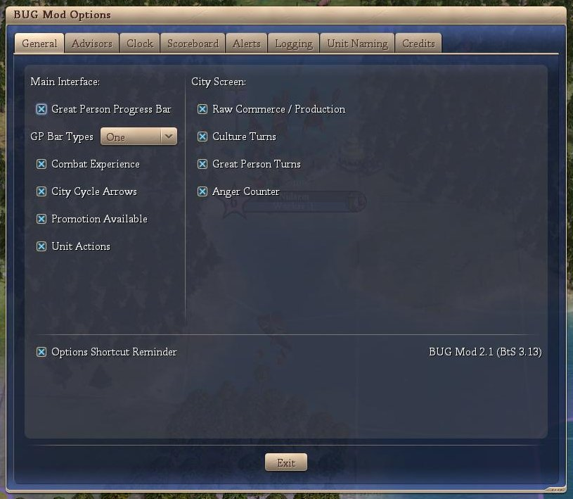

The individual General features are discussed below:
- Main Interface
  - Great Person Progress Bar
If checked, the Great Person Progress Bar is displayed. If the user clicks on the tab, the highlighted city screen is opened. There are three display options as illustrated below.
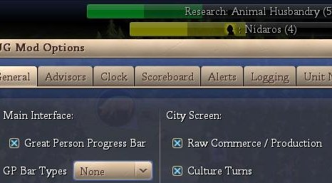
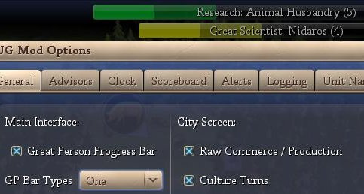
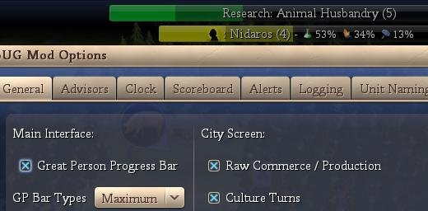
  - City Cycle Arrows
If checked, the City Cycle Arrows are displayed (see below). By clicking on the right / left arrows, the user is taken to the next city in the cycle while in the main interface screen.
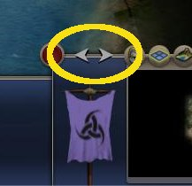
  - Combat Experience
If checked, the Combat Experience counter from the F5 screen is displayed (see below)
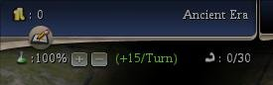
(the strong arm with the 0/30)
  - Promotion Available
If checked, a unit with a promotion available has a light blue highlight around its plot icon (see below).
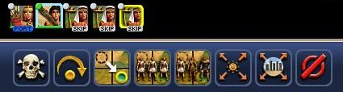
(the blue highlight around the warrior)
  - Unit Actions
If checked, a unit that has a pre-defined action (heal, goto, automated, fortified, etc) has text describing the action added to the bottom of its plot icon (see below).
(the ‘FORT’ on the archer signifying fortified and the ‘SKIP’ on the workers signifying that I have skipped those units for this turn).
- City Screen
  - Raw Commerce / Production
If checked, the City Screen shows the city’s raw production or commerce (see below). A button is available so the user can cycle between production or commerce. The source of the production or commerce is also shown.
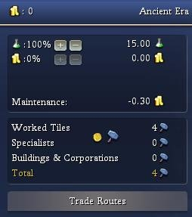 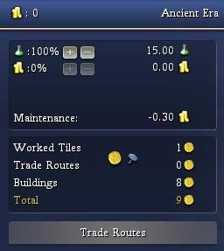
(city production) (city commerce)
  - Culture Turns
If checked, the number of turns to the next cultural level is displayed (see below). No turns are displayed if the city is already Legendary or the city is not producing any culture.
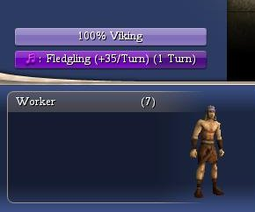
  - Great Person Turns
If checked, the number of turns to the next Great Person is displayed (see below). No turns are displayed if the city or the city is not producing any Great Person points.
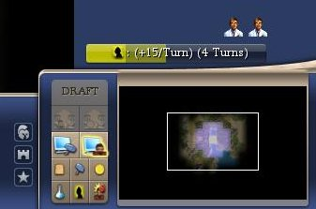
- Options Shortcut Reminder
if checked, the BUG options screen short cut is displayed (see below).
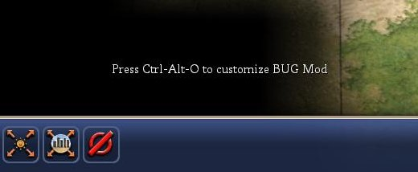

Conclusion
Opinion: It is our opinion that no additional information is presented to the user via this section of the BUG mod and it should be approved.

Advisors
This section will provide details about the Advisor features build into the BUG mod. Here is a screenshot of the options screen:
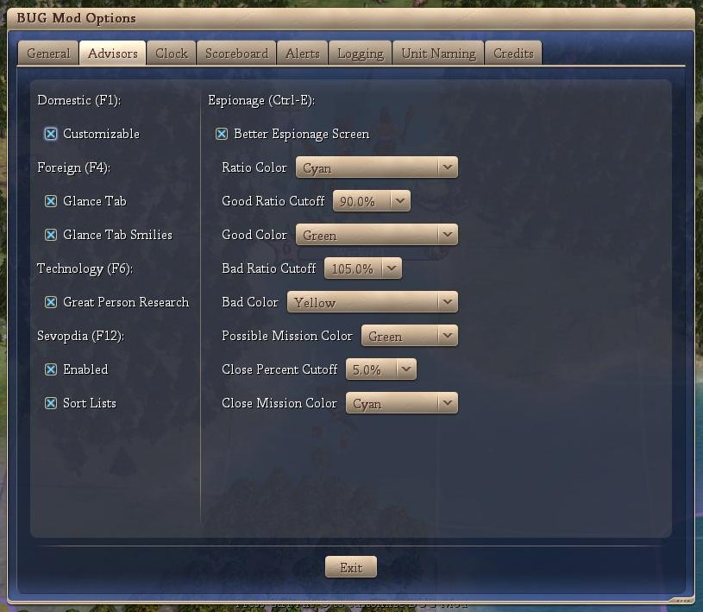
The individual Advisor features are discussed below:
- Domestic
If checked, then the built in Domestic Advisor is replaced with the Customizable Domestic Advisor (see below).
- Foreign
  - Glance Tab
If checked, the Glance tab is included
  - Glance Tab Smilies
If checked, the Glance tab includes Smilies similar to the scoreboard smilies
- Technology
  - Great Person Research
If checked, a row of great people followed by two techs are shown. The first of these two techs indicate the tech the great person would lightbulb. The second of these two techs indicates the tech the great person would lightbulb if the currently selected tech was known.
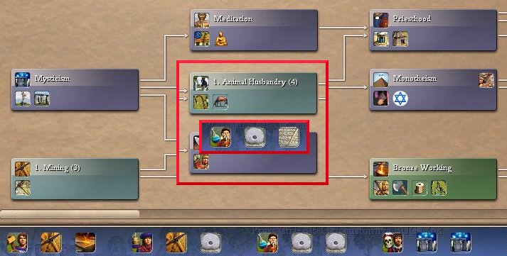
The above picture shows that a Great Scientist will lightbult roads and if you research mining, he will lightbulb roads. If, however, you research Animal Husbandry (insert), the Great Scientist will lightbulb writing.
- Sevopdia (see below)
  - Enabled
If checked, the in-game civopedia is replaced with the Servopdia.
  - Sort List
If checked, the lists are sorted.
- Espionage (Ctrl-E)
If checked, then the in-game Espionage advisor is replaced (see below).

Sevopedia
The following is from the initial post (edited for format) on the CFC forums regarding Sevopedia.

About SevoPedia
Greetings. I love cIV, but we all know that they dropped the ball with the civilopedia. It's impossible to navigate easily and non-intuitive in design. So this is an improvement. Sevo's Civilopedia (or...Sevo-lo-pedia, or even Sevopedia, but I digress...) This mod turns the civilopedia into a nicer, user-friendly, easy-to-navigate reference.
Features
    - Menus moved to left, with main menu on far left, sub-menu next to it
    - Main menu list reordered into groups with icons
    - Sub Menu organized into an easy to read list.
    - New in this version: Pictures included in list!
    - No more hopping away from the top screen when you select a page. The page comes up in the available to space on the right
    - Includes previously hidden entries (check out the barbarian leader...)
    - Will easily integrate with almost all existing mods
    - Can disable animations if desired
    - Vovan's Unit Upgrade Chart: Will automatically produce upgrade chart for units, even when modded!
From the above, the intention is to just reorganize the content of the civilopedia and thus it would appear that there is no spoilerish information provided. Discussion about what is in the CDA and why it isn’t spoilerish.
I’ve included a sample screenshot of the default civilopedia (top picture) and the corresponding item from the sevopedia (bottom picture).
It would appear that the Sevopedia is just a reorganization of the menu and the inclusion of the actual data page with the index to the left.
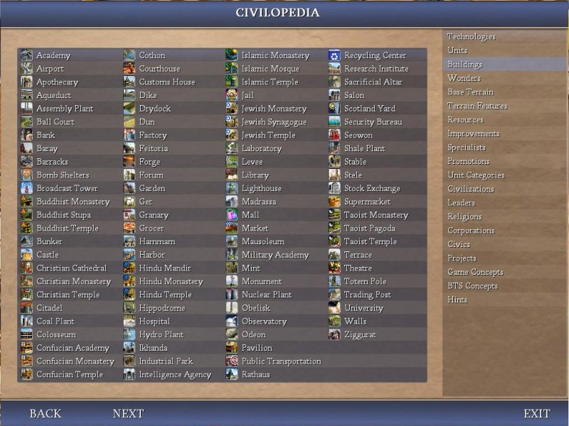
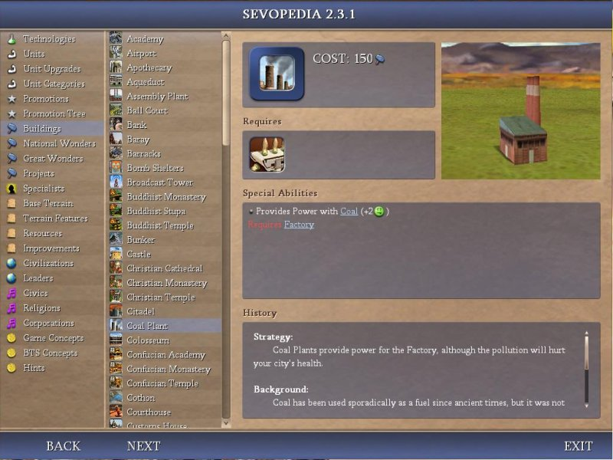
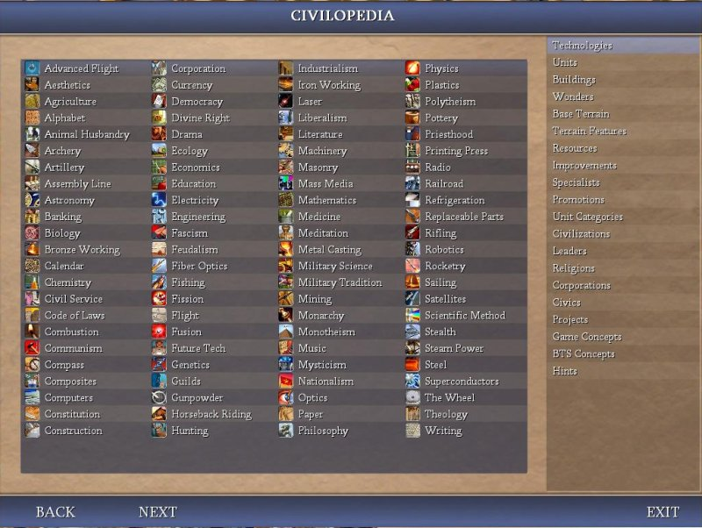
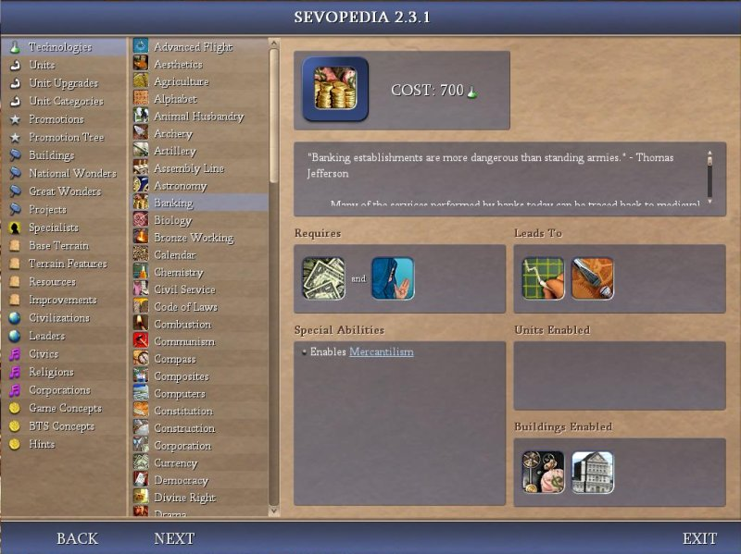
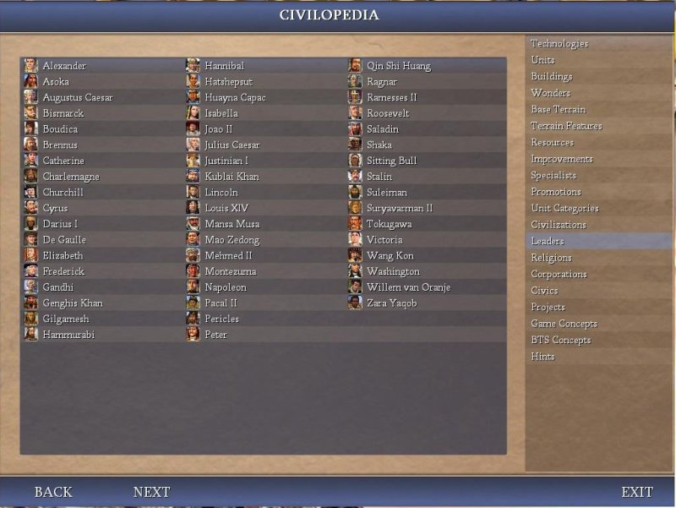
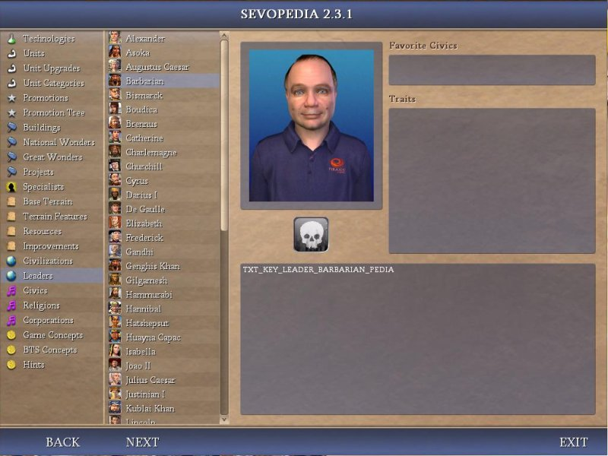

Customizable Domestic Advisor
The Customizable Domestic Advisor (CDA) has a default view that the user can modify. The default CDA contains approximately 5 pages. There is a version of the CDA configure file that contains many more pages. There are an unlimited number of pages that the user can add to the advisor. The following is a list of the columns that the user can add.
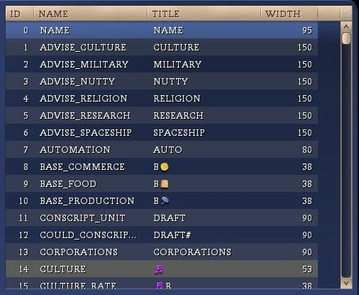
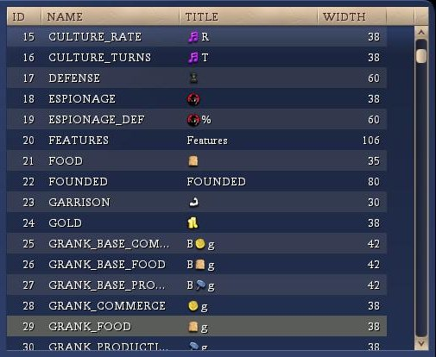
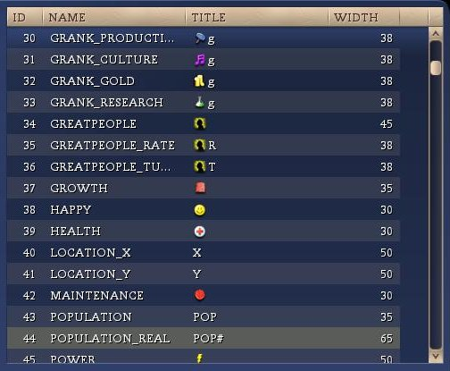
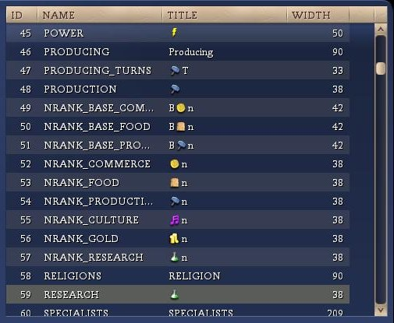
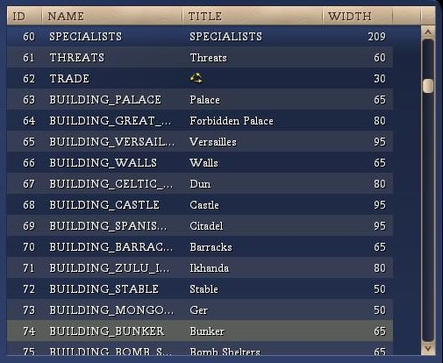
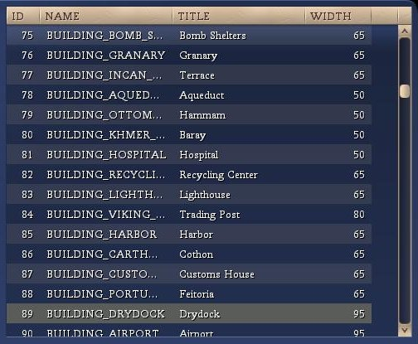
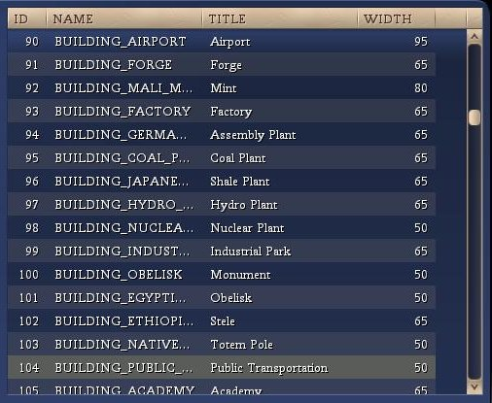
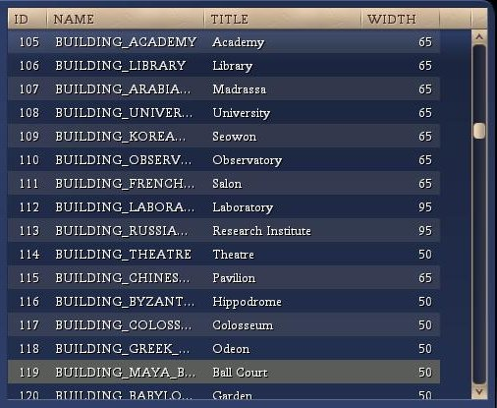
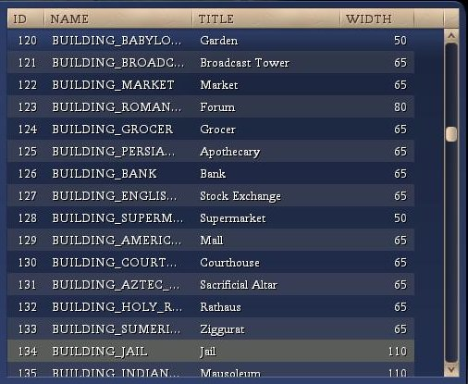
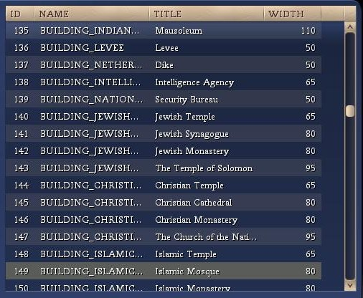
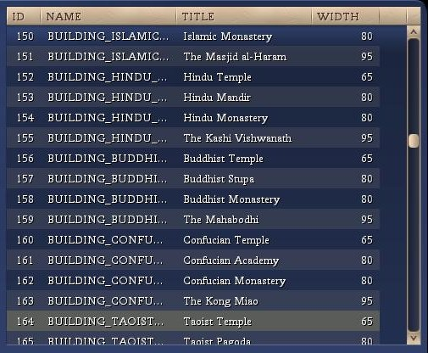
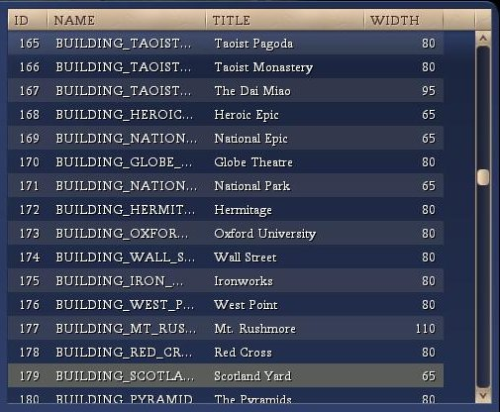
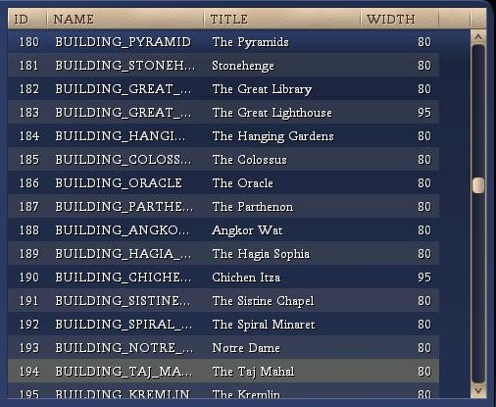
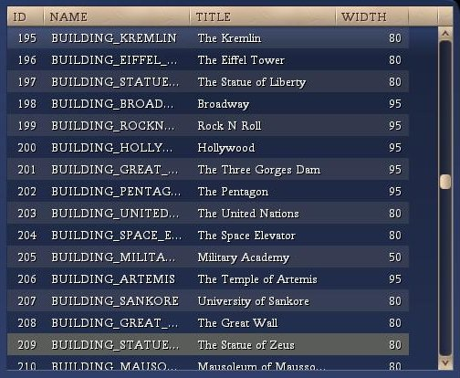
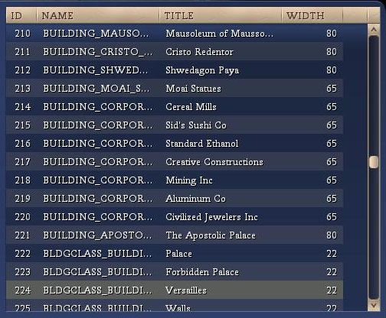
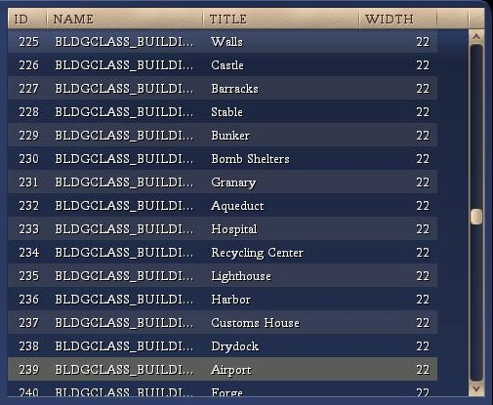
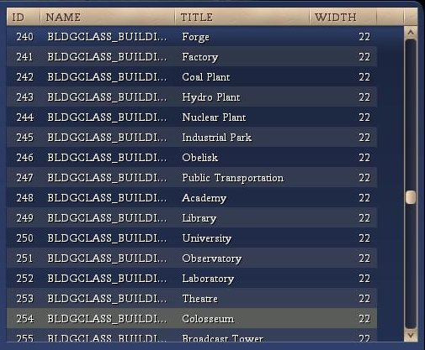
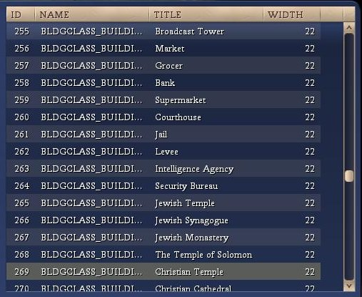
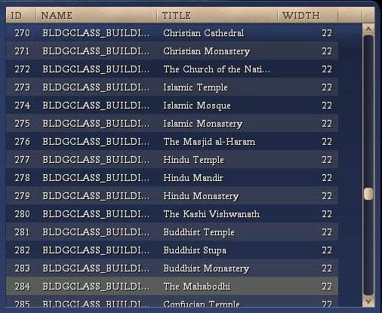
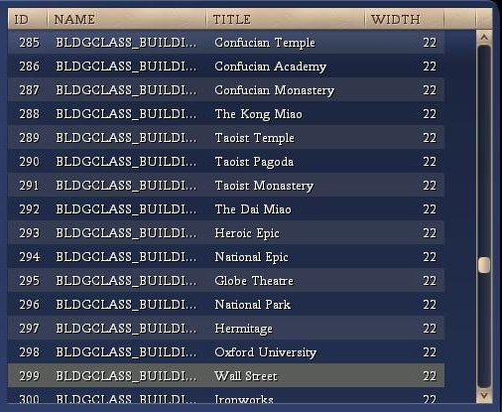
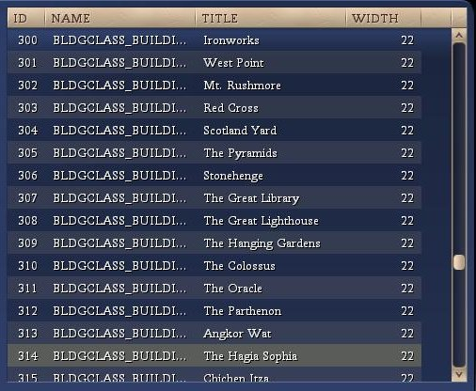
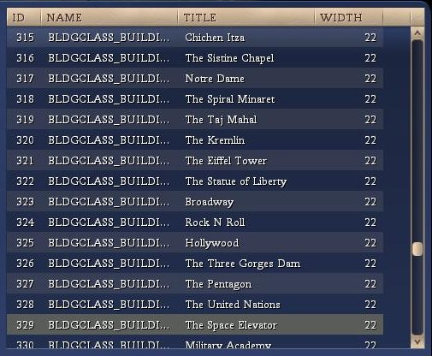
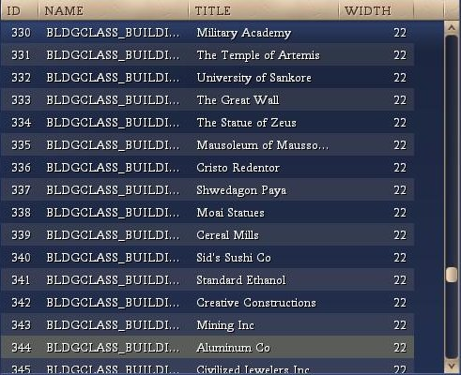
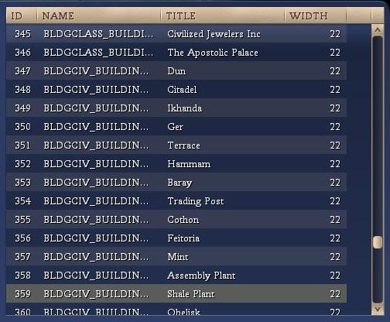
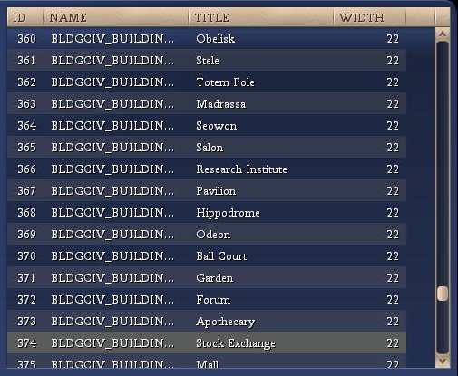
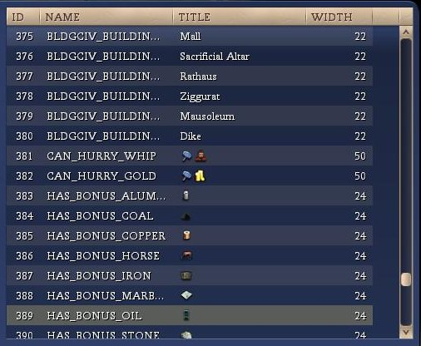
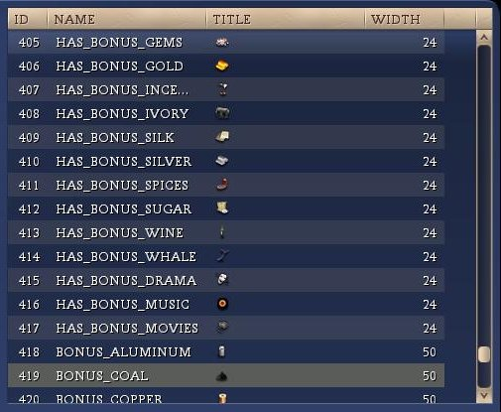
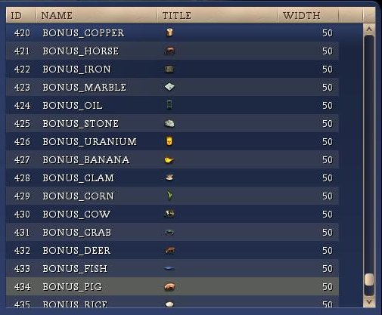
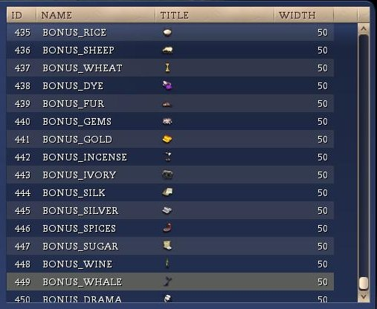
After review, the list of items does not contain spoiler information apart from the GRANK_* items. Those columns return the city’s rank on various items as measured against all other cities (known and unknown).
These columns are not shown in the default CDA or the supplied CDA configuration file. These columns would have to be explicitly ruled out for this mod to be approved by Realms Beyond.

BUG Espionage Advisor
The BUG version of the Espionage Advisor is similar to the standard BtS version except it adds color coding and rearranged some fields on the left of the screen.
The mission costs (close to being able to perform missing and can perform mission) are color coded as well as the relative cost of the missions.
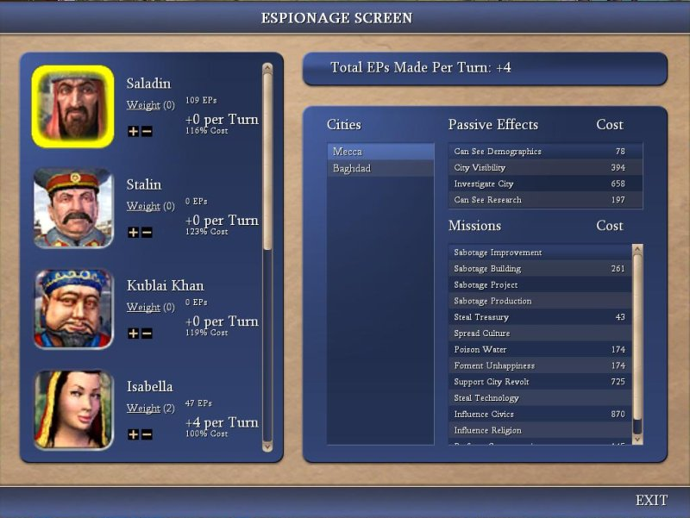(default version)
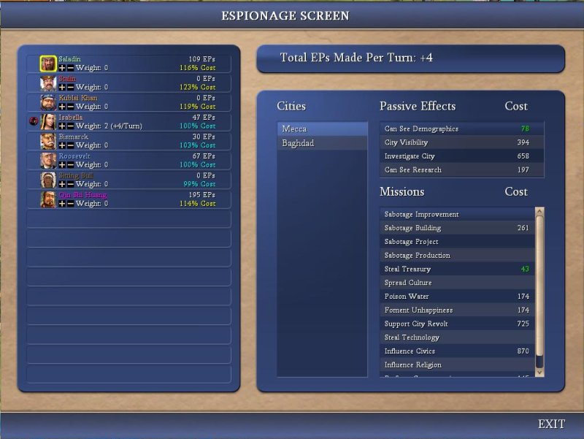(BUG version)

Conclusion
Opinion: It is our opinion that, providing the GRANK_* columns in the CDA are explicitly excluded for Realms Beyond, no additional information is presented to the user via this section of the BUG mod and it should be approved.

Clock
This section will provide details about the Clock features build into the BUG mod. Here is a screenshot of the options screen:
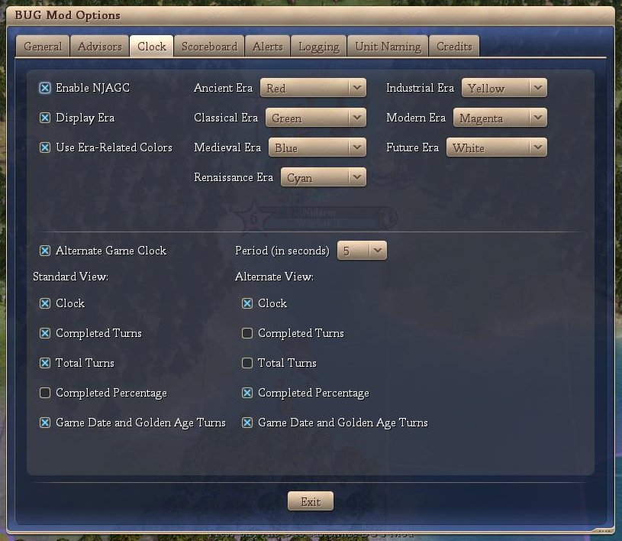
The individual Clock features are discussed below:
- Enable NJAGC (Not Just Another Game Clock)
If this option is checked then the Clock portion of BUG is enabled.
- Display Era
If checked, then the current era (according to the player) is displayed.
- Use Era-Related Colors
If checked, then the current era (according to the player) is displayed in the color that the user can specify (drop downs to the right).
- Alternate Game Clock
If checked, then the clock alternates between ‘Standard View’ and ‘Alternate View’. The user can specify the alternating time period in seconds. If not checked, only the ‘Standard View’ is displayed.
- Standard / Alternate View(s)
  - Clock
If checked, the time is displayed
  - Completed Turns
If checked, the time is displayed
  - Total Turns
If checked, the total turns for this game are displayed only if ‘time victory’ is enabled.
  - Completed Percentage
If checked, the percent complete (as measured by turns) is displayed only if ‘time victory’ is enabled.
  - Game Date and Golden Age Turns
If checked, the game date and Golden Age turns are displayed.

The following is a sample screen shot showing the Standard View.
(upper left)
 (upper right)
The following is a sample screen shot showing the Alternate View.
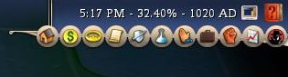 (upper right)

Conclusion
Opinion: It is our opinion that no additional information is presented to the user via this section of the BUG mod and it should be approved.

Scoreboard
This section will provide details from the scoreboard tweaks enabled by BUG. Here is a screenshot of the options screen:
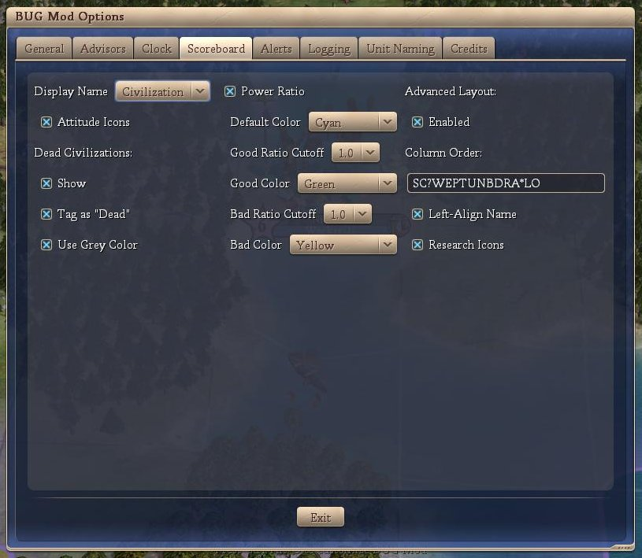

The balance of this section will detail each feature independently.
- Display Name
There are three (3) options in this drop down.
  - Name: Displays the leader name on the scoreboard. This is the default behavior of civilization.
  - Civ: Displays the civilization name on the scoreboard.
  - Both: Displays leader name / civilization name on the scoreboard.
- Attitude Icons
This option displays an icon next to the display name showing the civilization attitude towards the player. It’s the same as opening the Foreign Advisor screen or even hovering the mouse over the civilization name. The icons stand for:
  - Red Frowning Face: Furious
  - Cyan Frowning Face: Annoyed
  - Grey Straight Month Face: Cautious
  - Green Smiling Face: Pleased
  - Yellow Grinning Face: Friendly
- Dead Civilizations
This group of options shows how dead civilizations are displayed on the scoreboard. The options are:
  - Show
This is the default behavior of Vanilla and Warlords versions. BtS’ default is to hide the dead civilization.
  - Tag as “Dead”
This option replaces the zero score with the text “Dead”.
  - Use Grey Color
This option greys out the dead civilization.
- Power Ratio
This option displays the power ratio between your civilization and the indicated civilization expressed to 1 decimal place only. It is a ratio of your power to their power. Numbers greater than 1 indicate that you are stronger than them. There are options to use colors as a visual aid. The color options are:
  - Default color: Default display
  - Good Ratio Cutoff: values greater than this number will be considered good.
  - Good Color: Display color for power ratios higher than the ‘good ratio cutoff’
  - Bad Ratio Cutoff: values shorter than this number will be considered bad
  - Bad Color: Display color for power ratios lower than the ‘bad ratio cutoff’

Advanced layout
The Advanced Layout option is enabled if the user selects the ‘Enabled’. The ‘Column Order’ key is discussed in the table below. This key enables the user to modify the display order of items in the scoreboard. It also enables the user to remove items from the scoreboard.
The following table shows the keys available, some restrictions on their display (ie only for rivals) as well as differences between the BUG mod’s display and raw BtS. It also includes comments on the ‘Left-Align Name’ and ‘Tech Icons’ check boxes.
Advanced Layout Item |  | Description |  | Restrictions |  | Differences to raw BtS
S |  | The civ's score |  |  |  | Nil
C |  | The civ's/leader's name |  |  |  | Column same width for all leaders. Left aligned if the ‘Left-Align Name’ option is checked
? |  | Shows a ‘?’ if you haven't met the civ of a human player yet in a multi-player game (PBEM, Hotseat, pitboss) |  | Multi-player only. |  | Nil
W |  | Current WAR status |  | Rivals Only |  | Fist displayed instead of ‘WAR’
E |  | Shows a spy icon if you have a positive espionage point ratio against the civ |  | Rivals Only |  | Nil
P |  | The civ's power ratio |  | Rivals Only |  | See above
T |  | The tech the civ is researching (vassals, teammates and espionage) |  | Rivals Only |  | Nil unless ‘Research Icons’ option is checked in which case the tech icon is shown
U |  | The number of research turns left (see T above) |  | Rivals Only |  | Nil
N |  | Shows the three-arrow icon when you are connected to the civ's trade network |  | Rivals Only |  | Nil
B |  | Shows a scroll icon when you have signed an open borders agreement with the civ |  | Rivals Only |  | Nil
D |  | Shows a similar scroll icon when you have signed a defensive pact with the civ |  | Rivals Only |  | Nil
R |  | The civ's state religion |  |  |  | Nil
A |  | The civ's attitude toward you |  | Rivals Only |  | See above
* |  | You are waiting for this civ to finish its turn |  | Online multi-player only |  | Nil
L |  | The civ's network stats (ping) |  | Online multi-player only |  | Nil
O |  | The network player is out-of-sync |  | Online multi-player only |  | Nil

Conclusion
Although a very heavy programming mod, the only additions to the raw BtS scoreboard display is the inclusion of attitude icons and the power rating. There is nothing of a spoiler nature with either of these as the Civilization attitude can be gathered from F4 while the power ratio can be estimated from the power graphs.
Opinion: It is our opinion that no additional information is presented to the user via this section of the BUG mod and it should be approved.

Alerts
This section will provide details about the Alert features build into the BUG mod. Here is a screenshot of the options screen:
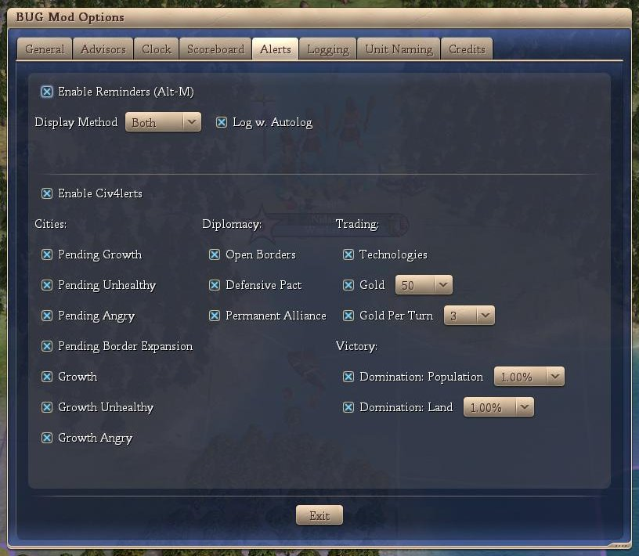

Reminders
The individual Reminder features are discussed below:
- Enable Reminders (Alt-M)
If this options is checked, then the Reminder portion of BUG is enabled. You can store a reminder via Alt-M on the keyboard. This will bring up a dialog box (see below) and you can set a reminder text as well as a reminder turn.
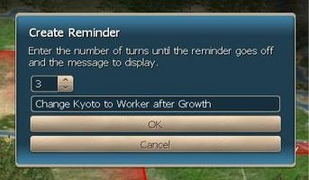
Then after the number of turns you specify, another dialog box pups up (see below – note this is not the show associated with the above dialog box) with your reminder. Reminders are stored across saves.
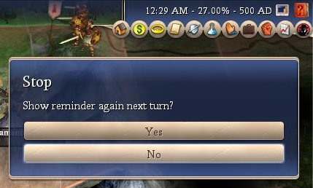
You can set the same reminder to appear next turn if you so desire.
- Display Method
This is the display method for the reminder. The options are:
- dialog box (as above)
- message on screen with other Civ4 messages
- both
- Log w. Autolog
When checked, this logs the setting and firing of reminders in the autolog / logger (the logger must also be enabled).

Alerts
The individual Alert features are discussed below:
- Enable Civ4lerts
If this options is checked, then the Civ4lerts portion of BUG is enabled.
- Cities
  - Pending Growth
If checked, an alert that a city will grow next turn is displayed.
  - Pending Unhealthy
If checked, an alert that a city will grow into unhealthy (or further into unhealthy) next turn is displayed.
  - Pending Angry
If checked, an alert that a city will grow into anger (or further into anger) next turn is displayed.
  - Pending Border Expansion
If checked, an alert that a city border expansion will occur next turn is displayed.
  - Growth
If checked, an alert that a city has grown this turn is displayed.
  - Growth Unhealthy
If checked, an alert that a city has grown into unhealthy (or further into unhealthy) is displayed.
  - Growth Angry
If checked, an alert that a city has grown into anger (or further into anger) is displayed.
- Diplomacy
  - Open Borders
If checked, an alert that a civilization will sign open borders is displayed (first turn that option is available only).
  - Defensive Pact
If checked, an alert that a civilization will sign a defensive pact is displayed (first turn that option is available only).
  - Permanent Alliances
an alert that a civilization will sign a permanent alliance is displayed (first turn that option is available only).
- Trading
  - Technologies
If checked, an alert that a technologies to trade is displayed (first turn that tech is available only).
  - Gold
If checked, an alert that a civilization has gold to trade is displayed (each turn) – the user can set the limit of the alert.
  - Gold per Turn
If checked, an alert that a civilization has gold per turn to trade is displayed (each turn) – the user can set the limit of the alert.
- Victory
  - Domination: Population
If checked, an alert that you are approaching or exceeded the population domination limit - user can set the amount below the population domination limit that activates the alert.
  - Domination: Land
If checked, an alert that you are approaching or exceeded the land domination limit - user can set the amount below the land domination limit that activates the alert.

Conclusion
Opinion: It is our opinion that no additional information is presented to the user via this section of the BUG mod and it should be approved.

Logging
The BUG mod includes a logging portion that logs the general events that occur in the game to a text file. This is mainly included for succession game (SG) players as a way of recording the mundane events that occur. Typically, SG players / events have house rules concerning the use (or otherwise) of loggers.
The options shown on the BUG mod’s logging option screen are shown below.
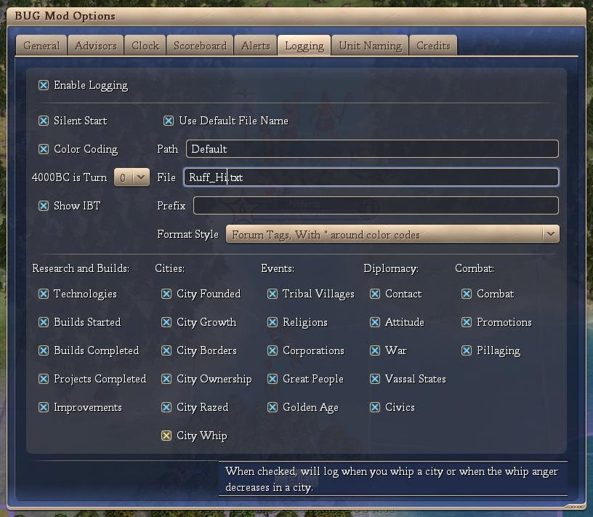
These features are discussed below:
- Enable Logging
If this options is checked, then the logging portion of BUG is enabled and logging will occur. If this options is not checked, then the logging portion of BUG is not enabled and logging will not occur.
- Silent Start
This option means that logging of the game will automatically start and the file name will be set to the name of the player. In the above graphic, the game was started by the player ‘Ruff_Hi’ and the logging will be written to a file ‘Ruff_Hi.txt’ that is in the default file path (my docs\BtS\autolog).
- Color Coding
If color coding is checked, then the log will include various color characteristics that group the events being logged by color. The user cannot adjust the colors.
- 4000BC is turn ?
The logger includes code to count 4000BC as Turn 0 or Turn 1. The user can specify which counter they wish to use.
- Show IBT
If this option is checked, then the logger will include a line that contains “IBT:” at the conclusion of the players turn and prior to the AIs turns.
- Use Default File Name
If ‘Silent Start’ is not checked, then the player must start the logger manually. The key to start the logger is Alt-L. If the ‘Use Default File Name’ option is checked, then the default name (Player’s Name) is used for the text file. If the ‘Use Default File Name’ option is not checked, then the player must supply a file name via an input box.
- Path
The player can over-ride the default path for the location of the logging file.
- File
The player can over-ride the default file name.
- Prefix
The player can manually add a comment to the log file (Alt-E). The logger records this manual entry with the addition of the ‘Prefix’.
- Format Style
There are four (4) format styles available for the log file. None: no formatting, HTML: html tags are included, Forum with ‘“’: Forum tags with ‘“’s around the color text (if any) are included, Forum without ‘“’: Forum tags without ‘“’s around the color text (if any) are included.
- Research and Builds
  - Technologies
If checked, technologies gained through research or trade are logged, Technologies started are logged together with the game’s estimate of the number of turns to complete.
  - Builds Started
If checked, city builds (either buildings, wonders or units) started are logged together with the game’s estimate of the number of turns to complete
  - Builds Completed
If checked, city builds (either buildings, wonders or units) completed are logged.
  - Projects Completed
If checked, city builds (projects) completed are logged.
  - Improvements
If checked, city improvements (cottages, farms, mines, etc) are logged.
- Cities
  - City Founded
If checked, cities founded are logged.
  - City Growth
If checked, city growth is logged.
  - City Borders
If checked, city border expansions are logged.
  - City Ownership
If checked, city ownership, or change in ownership, is logged.
  - City Razed
If checked, city destruction is logged.
  - City Whipped
If checked, rushing the build queue via whipping is logged as well as when the city whip anger decreases.
- Events
  - Tribal Villages
If checked, the result from tribal villages is logged.
  - Religions
If checked, the founding or spread of religions is logged.
  - Corporations
If checked, the founding or spread of corporations is logged.
  - Great People
If checked, the birth of Great People is logged.
  - Golden Age
If checked, the start and end of Golden Ages are logged.
- Diplomacy
  - Contact
If checked, initial contact between the player and other civilizations is logged.
  - Attitude
If checked, attitude changes between known civilizations is logged.
  - War
If checked, the war status between known civilizations is loggedError: Reference source not found.
  - Vessel States
If checked, the vessel state status between known civilizations is loggedError: Reference source not found.
  - Civics
If checked, civic changes of known civilizations are logged.
- Combat
  - Combat
If checked, combat between the player’s units and units from another civilization is logged Also logged are the results, general location, victory probability and remaining health of the victorious unit.
  - Promotions
If checked, promotions granted to the player’s units are logged.
  - Pillaging
If checked, pillaging performed by the player’s units regardless of location or pillaging by the AI units on the player’s tiles, is logged.

The following is a sample of a typical log file.
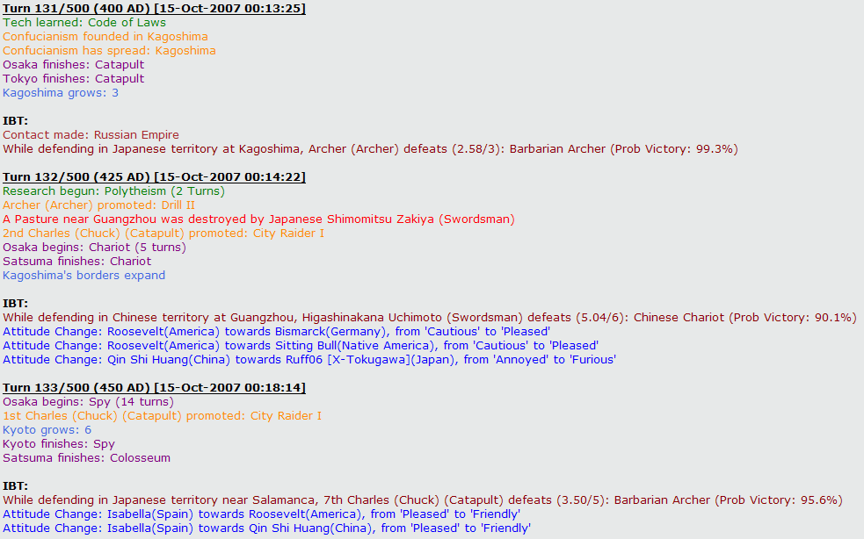

Conclusion
Opinion: It is our opinion that no additional information is presented to the user via this section of the BUG mod and it should be approved.

Unit Naming
The BUG mod includes the Generic Unit Naming (GUN) mod. This mod is designed to give the player an extremely flexible method of naming his units. The basic approach is that the player constructs a naming convention that they want to use (see later) and then assigns that naming convention to all units, all units of the same combat type or all units of the same unit type in the same era.
The options shown on the BUG mod’s Unit Naming option screen are shown below.
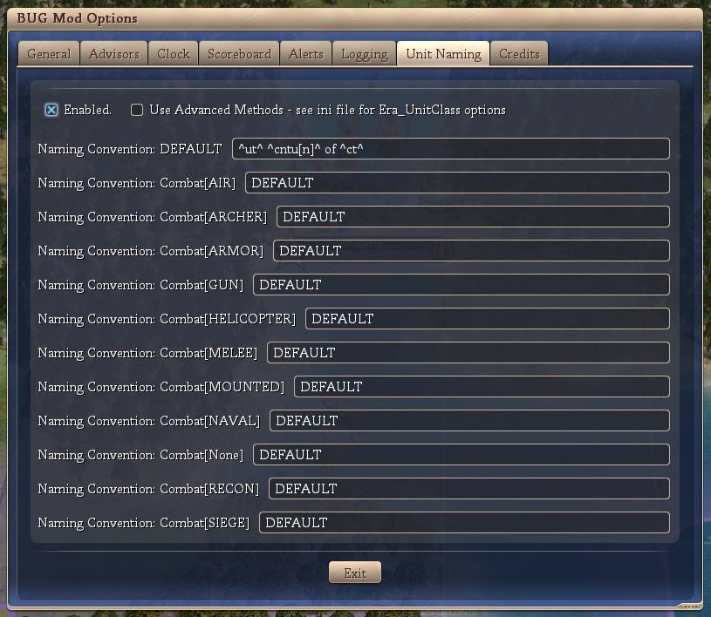
These features are discussed below:
Enabled
If this option is checked, then the unit naming portion of BUG is enabled and units produced will be given a name depending on the player defined naming convention. If this option is not checked, then the unit naming portion of BUG is not enabled and default Civ4 unit naming will occur.
Use Advanced
If checked, than the unit naming code will extract the naming convention from the BUG mod ini using the unit type and the current player era. If this naming convention is “DEFAULT”, then the naming convention associated with the unit’s combat type will be used. If this naming convention is “DEFAULT”, then the ‘default’ naming convention will be used.
For example: An axe constructed in the ancient era will use the naming convention stored with the ini key “AXE_ANCIENT”. If this naming convention is “DEFAULT”, then the naming convention stored with the ini key “Melee” will be used. If this naming convention is “DEFAULT”, then the naming convention stored with the ini key “DEFAULT” will be used.
If this option is not checked, then the naming convention associated with the unit’s combat type will be used. If this naming convention is “DEFAULT”, then the ‘default’ naming convention will be used.
The balance of the screen shows the various naming conventions used for the 10 combat types in the game. An 11th quasi-combat type (None) has been added for settlers, workers, missionaries, etc.

Naming Conventions
The following is the code that controls the name that your unit will have.
^civ4^ - no naming convention, uses standard civ4
^rd^ - random name
^rc^ - random civ related name
^ct^ - City
^cv^ - Civilization
^ut^ - unit (eg Archer)
^cb^ - combat type (Melee)
^dm^ - domain (Water)
^ld^ - leader
^cnt[f]^ - count across all units (increments based on unit)
^cntu[f]^ - count across same unit (increments based on unit)
^cntct[f]^ - count across same city (increments based on unit)
^cntuct[f]^ - count across same unit / city (increments based on unit)
^cntc[f]^ - count across same combat type (increments based on combat type)
^cntd[f]^ - count across same domain (increments based on domain)
^tt1[f][x:y]^ - total where the total is a random number between x and y (number)
^tt2[f][x]^ - total count (starts at x, incremented by 1 each time ^tt1 is reset to 1)

There are a number of number formats, as follows:
[f] can be either 's', 'A', 'a', 'p', 'g', 'n', 'o' or 'r' for ...
silent (not shown)
upper case alpha (A, B, C, D, ...)
lower case alpha (a, b, c, d, ...)
phonetic (alpha, bravo, charlie, delta, echo, ...)
greek (alpha, beta, gamma, delta, epsilon, ...)
number
ordinal (1st, 2nd, 3rd, 4th, ...)
roman (I, IV, V, X, ...)

Some number formats have a built in max (i.e. alpha). In these situations, the numbering loops back to the start. For example, if you pass the number ‘30’ and ask for the number to be formatted with an ‘A’ (upper case alpha) then it will return ‘D’.

Conclusion
Opinion: It is our opinion that no additional information is presented to the user via this section of the BUG mod and it should be approved.

Credits
This section will provide a screen shot(s) of the Credit tab from the ‘BUG Mod Options’ screen (below).
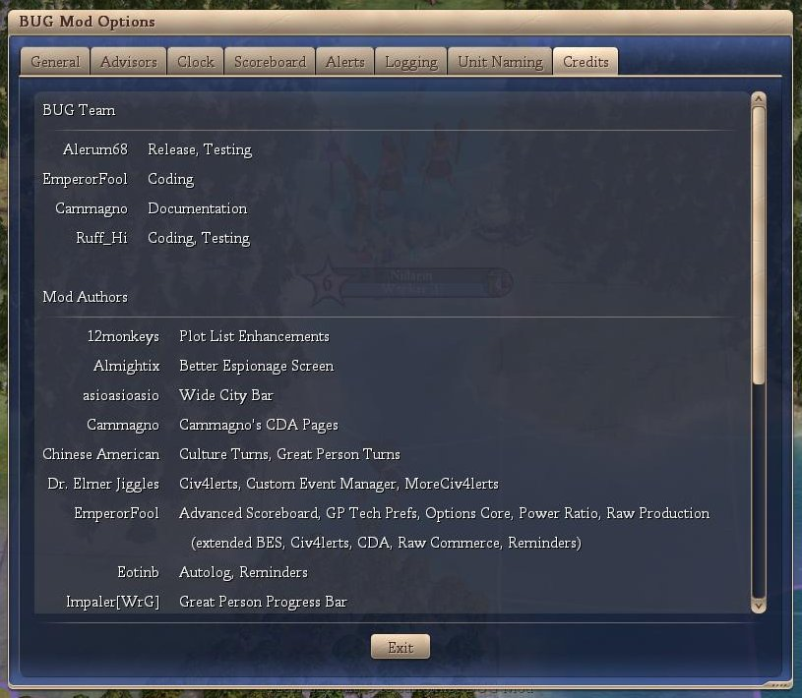
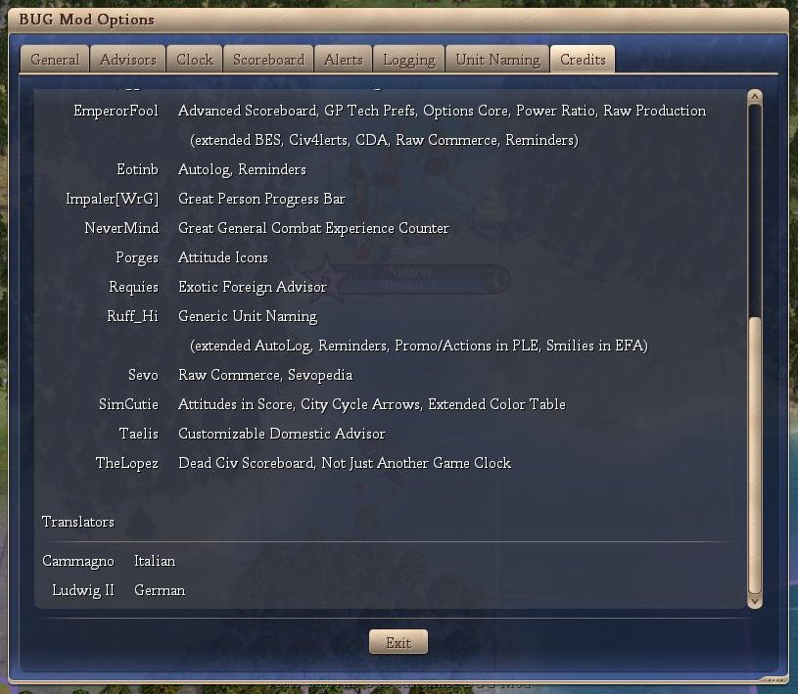

Conclusion
Opinion: No approval required, no spoiler information provided.

If you ignore the inclusion of the barbarian leader which doesn’t seem like a very big deal.
This information is only displayed if you have enough espionage points to gather the required information.
IBT stands for “In between Turns”.
Note: Both civilizations must be known to the player.

